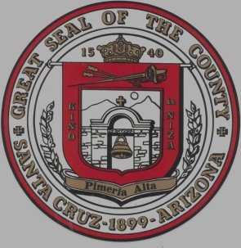
SANTA CRUZ COUNTY PROVISIONAL
COMMUNITY COLLEGE
DISTRICT GOVERNING BOARD MEETING

Notice

SPECIAL STUDY SESSION OF THE GOVERNING BOARD OF THE
SANTA CRUZ COUNTY PROVISIONAL COMMUNITY COLLEGE DISTRICT

Pursuant to A.R.S. 38-431.02, notice is hereby given to the members of the Governing Board of the Santa Cruz County Provisional Community College District Governing Board, and to the general public, that the board will hold a SPECIAL STUDY SESSION open to the public on Saturday, August 18, 2018 at 9:00 am at the Santa Cruz Center, 2021 North Grand Avenue, Board Room, Nogales, AZ 85621.

AGENDA

1. GENERAL FUNCTIONS

1.01 Call to Order

1.02 Pledge of Allegiance

2. NEW BUSINESS ACTION

2.01 Discussion and possible action to recruit SCCPCCD Chief Financial Officer.

2.02 Discussion and review of progress on strategic planning, legislative updates, and goals on SCCPCCD for governing board members.

4. ADJOURNMENT

The public is invited to check for addenda, which may be posted up to 24 hours prior to the meeting. This information may also be obtained through the office of the Santa Cruz County Provisional Community College District Executive Director/CEO at 2021 N. Grand Avenue, Nogales, AZ, 85621, (520) 394-7181.

If you will require an accommodation to participate in this event, please notify Dr. Stella Perez at the above phone number at least 24 hours prior to the scheduled meeting.

GOVERNING BOARD OF THE SANTA CRUZ COUNTY
PROVISIONAL COMMUNITY COLLEGE BOARD

I, Aleisdy Palazuelos, certify that this notice of public meeting, prepared pursuant to A.R.S.
§38-431.02, was posted on xx/xx/2018 @5:00 p.m.
Aleisdy Palazuelos
Aleisdy Palazuelos
Santa Cruz County Provisional Community College
Governing Board & CEO Administrative Assistant

Official Postings:
santacruzcenter.org
Santa Cruz County Board of Supervisors Office
Santa Cruz Center, Nogales, AZ

Notices:
Santa Cruz County School Superintendent’s Office

